Google Colab Runtime (CPU vs GPU)

Figure 1: CPU Runtime
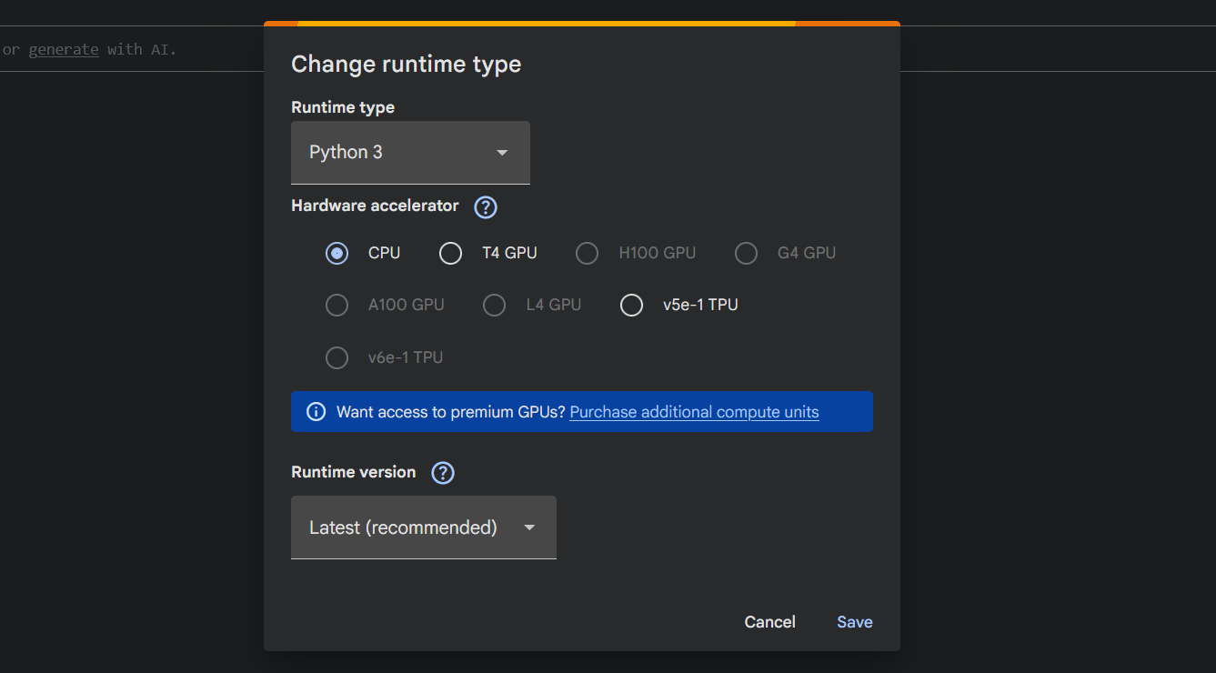

Figure 2: GPU Runtime
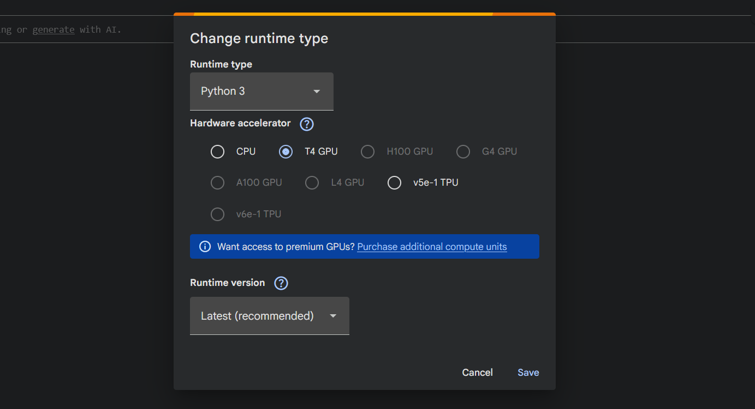
Google Colab allows switching between CPU and GPU for model execution.

